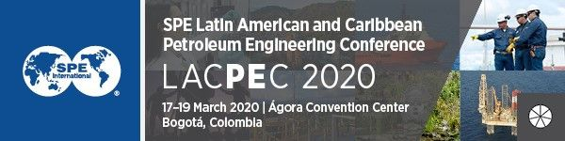
ADVANTAGES OF ATTENDING
When you propose this opportunity focus on what you will specifically bring back to the company as return on investment.
Some specific details you will need to identify include:
Make sure you include your interests and requirements to help prove the personal gain from attending the SPE Latin American and Caribbean Petroleum Engineering Conference (LACPEC).
Learn from—Technical Program | What sessions have particular relevance to your organization’s work? Which session in particular can you benefit from while working on existing/upcoming projects?  List 3 sessions and projects:  1.  2.  3.
Network—Daily Luncheons and Exhibition | Connect with and widen your existing network through the event with various opportunities to strike conversations and discuss projects and ideas with peers.  List 3 of new contacts attending the event:  1.  2.  3.
Advance—‘Ask E&P Experts’ Interactive Sessions | There are many opportunities to acquire new skills and knowledge on relevant subjects. Take back these learnings and share them with your team to enhance your work. List here which particular area(s) of learning you feel will benefit you and why:

