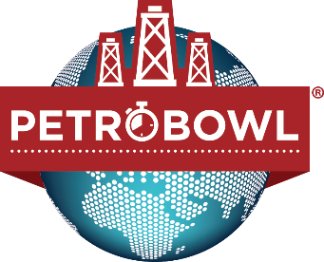

Virtual 2021 MENA Regional PetroBowl® Qualifiers Registration Form

The Virtual RQ will be hosted on the 14th and 15th of June 2021 by the SPE Kingdom of Saudi Arabia Section.
Please fill the attached application form to participate in the competition and send it to Ms. Rabab Meshikhes rabab.meshikhes@aramco.com & Mr. Hamoud Alkhaldi hamoud.alkhaldi@aramco.com
by 18th of May 2021.
We hope to see all of the chapters enrolled and get the benefit of the virtual venue.
Country:
University Name:
Sponsoring Section:
Team Members |  | Email | SPE ID | Nationality | Year in University | Work Experience
Chapter’s Advisor
Team Leader
Member 1
Member 2
Member 3
Member 4

For any further clarification, please feel free to contact Ms. Meshikhes or Mr. Alkhaldi. We look forward to your Chapter participation.

