Part 1: Setting up accounts
If you plan on charging a fee for an event then you will need a bank and PayPal Account. Use links below.
Need help creating a PayPal Account? Click Here
Need help setting up a Bank Account? Contact technicalsections@spe.org
Need help creating a Zoom Account? Click Here

IMPORTANT NOTE:
Your Technical Section must have its own bank account If the event registration you are creating requires a fee or payment using the below choice:
- Events with Registration and Payment
If your Technical Section does not have its own bank account and uses funds on account with SPE, you may still use the following:
- Events with External Registration
- RSVP Only – No Payment
Part 2: Event Payment Setup
Before adding an event, decide if you plan to accept payment electronically (requires a bank account- see below). If not, skip this part and go to the Add Event section.
If you plan to accept payment, first set up your preferred event payment provider.
Click Settings at the top right-hand corner of the screen. Then click Event Payment Providers.

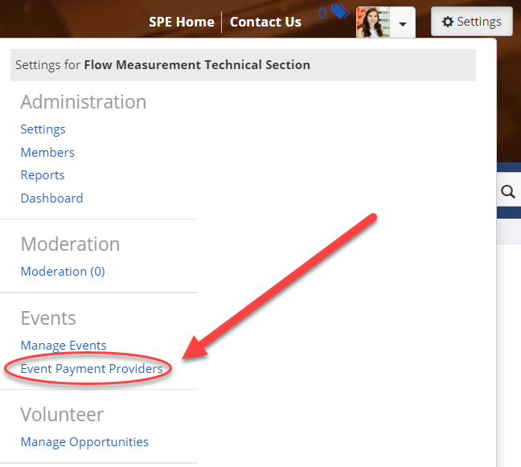
There are three options in the Payment Provider drop-down menu:
- CyberSource Secure Acceptance - not recommended
- PayPal Express Checkout - highly recommended*
- Stripe Checkout - not recommended
Then, fill out your section's payment gateway information; then click Save. You are responsible for your PayPal account and bank account.

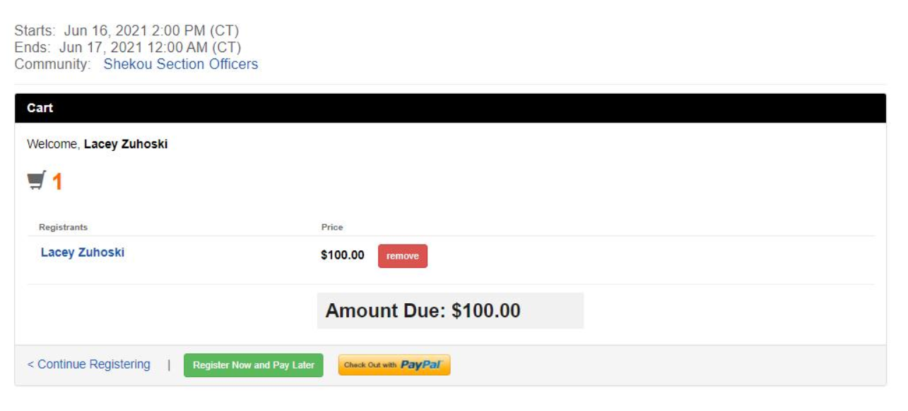
Note: If your event requires payment, each registrant will be given a Register Now and Pay Later option at checkout. No action required. This option is intended only for paying at the door of an in-person event.
Adding an Event
Select the Add Event button.
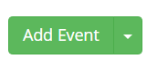

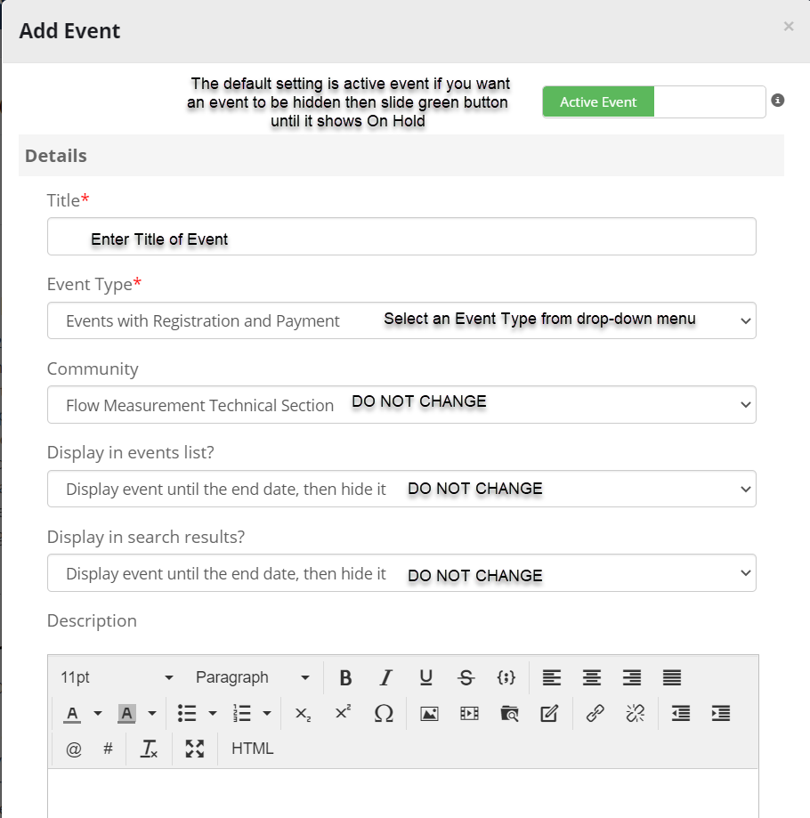

Types of Events located on Event Type Dropdown
- Calendar Only – No Registration of any Kind – External - DO NOT USE
- Calendar Only – No Registration of any Kind – No Reg - DO NOT USE
- Events with External Registration
- Note: We are unable to verify membership this way.
- Examples of when to use: To promote a webinar that is located on the webevents.spe.org page.
- Events with Registration and Payment – Recommended*
- Automatic verification of membership
- Does not allow for late registration. Must manually register after registration deadline. FTS
- Events with Payment – DUPLICATE DO NOT USE
- RSVP Only – No Payment - Recommended*
- zADMIN USE ONLY – Events with Sessions and Options – External – DO NOT USE
- zADMIN USE ONLY – Events with Sessions and Options – Full – DO NOT USE
- zADMIN USE ONLY – Events with Sessions and Options – No Reg -DO NOT USE
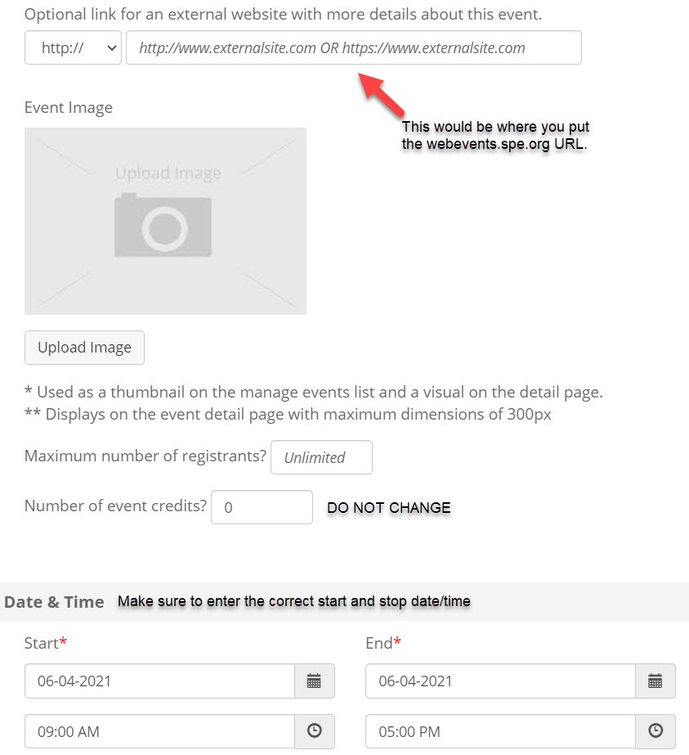

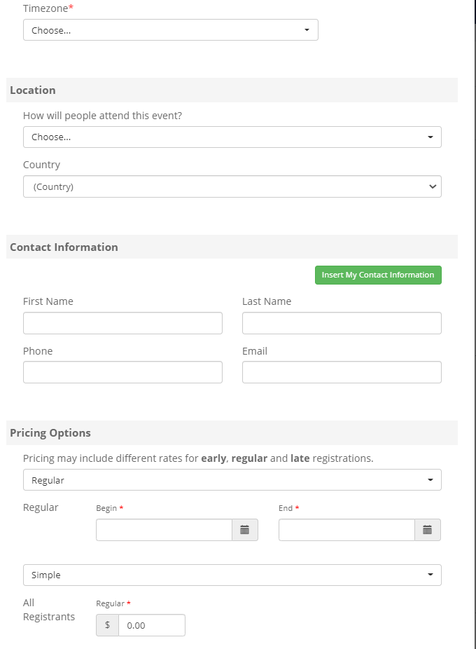
Pricing Options
- Regular – Default. Used in most cases. No early or late options.
- Early – Optional. Use in addition to regular if you would like to offer an “early bird” discount.
- Late – Optional. Use in addition to regular if you want to charge an additional fee for late registrations.
Registrant Classes
Select the types of registrants.
Simple — Default. Everyone pays the same price.
Member / Non-member / Guest / Student / Unemployed / Sponsor — Member price lower than non-member price. Prices can vary by category.

Member / Non-member / Guest / Student — Automatically verified.
Unemployed — Not verified. Honor system.

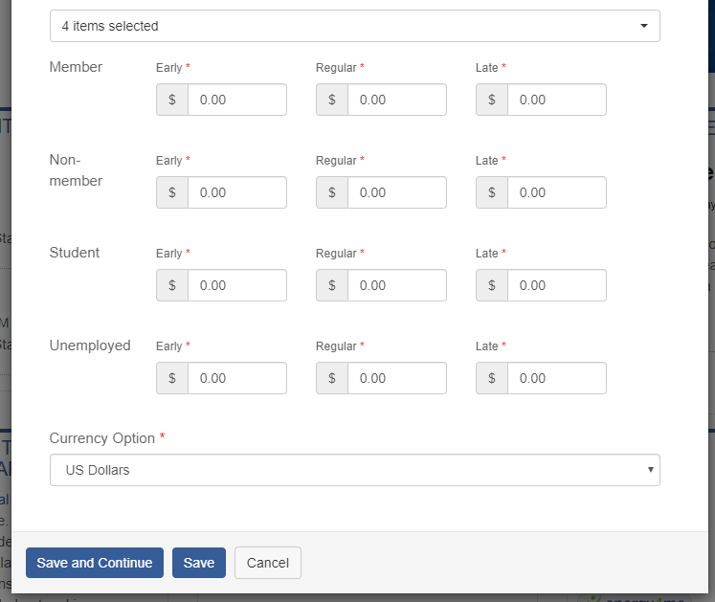

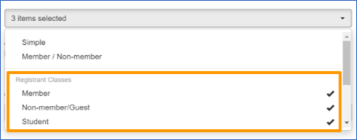
Automated Emails to Registrants and Officers are
Registrants receive the following messages:
- Registration confirmation (date, location, payment status)
- Registration receipt
- When an event is cancelled
- When an event’s details are changed
- To confirm cancellation initiated on their end
- When an event has reached maximum capacity

The event creator receives the following messages:
- When someone registers for an event
- When a registrant cancels
- When an event has reached maximum capacity

Note: Event emails cannot be modified.

Managing an Event
Select the Settings button in the top right corner of the site. Then, select Manage Events.

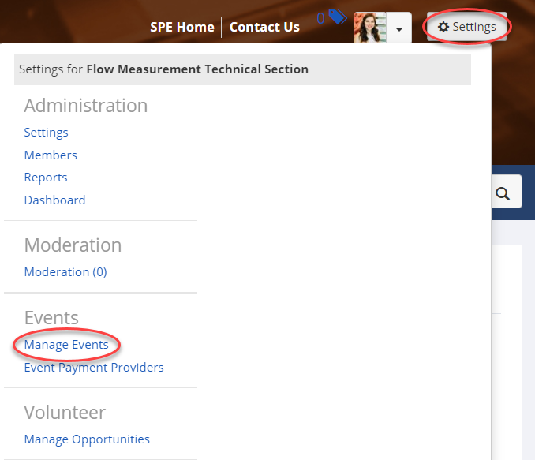

Select the Edit button drop down menu.
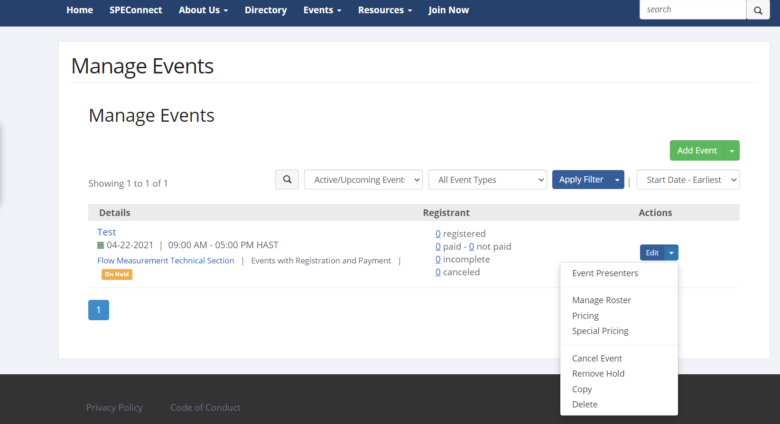

- Event Presenters — You can give speakers a special or free price for the event through this link.
- Manage Roster — View or export roster of registrants and payments.
- Pricing — Modify pricing (only available if no one has registered).
- Special Pricing — do not use. Set up registrant category pricing instead.
- Cancel Event – Refunds are done through the payment provider. HL's platform cannot manage refunds in any way.
- Hold/Remove Hold – Hides the event from public. Assessable by admin for reference in the future. (Ex. Copying or Postponing Event)
- Copy — Duplicates an event for faster set up. (Ex. Webinars that are similar format)
- Delete — Permanently deletes the event. This cannot be undone. Use Hold option instead.

