Informz Broadcast Email User Guide
September 2020

Table of Contents
Determine which Target Group(s) you want to email. 2
Log into Informz. 2
Create a Mailing. 3
Set-Up tab 3
Targeting Emails 5
Design tab 6
Personalization Codes 7
Images 8
Distinguished Lecturer Templates (Story Layouts) 8
Creating a Downloadable Calendar Appointment (vCalendar) 9
Test tab 11
Send tab 12
View your reporting. 13
Tips to Avoid Spam Filters 14

Determine which Target Group(s) you want to email.
Target groups are category lists of members.
Email communications are more effective when targeted to their audience. Informz allows you to include tailored messages, such as lapsed members or soon-to-graduate members, with specific calls for action to renew their membership.

Possible Available Section Target Lists (You may not see all these options):

- Professional Members (No Students): professionals paid for the current year, no students
- Members Unpaid: professionals who were paid last year but have not renewed for the current year
- Members and Students: professionals and students paid for the current year
- New Members from Previous Month: professionals, paid for the current year, who were new to your section last month
- Section Officers: current officers listed on the roster, paid and unpaid for the current year
- Senior professionals: professionals aged 55+, paid for the current year
- Young Professionals: professionals aged 36 or younger, paid for the current year

Log into Informz.
- You must have Java downloaded on your computer to use Informz broadcast email.
- Log into Informz using your usual SPE credentials. There is not a shared username and password for all officers. Only current, paid officers, listed on the roster have access.
Section Officers: http://www.spe.org/emailsections
Student Chapter Officers: http://www.spe.org/chapters/emails

Home Screen
Shows recent mailings sent by the officers of your section/student chapter. Select a mailing to view detailed reports on its success. Also view recently edited mailings, scheduled mailings, and mailings by month.
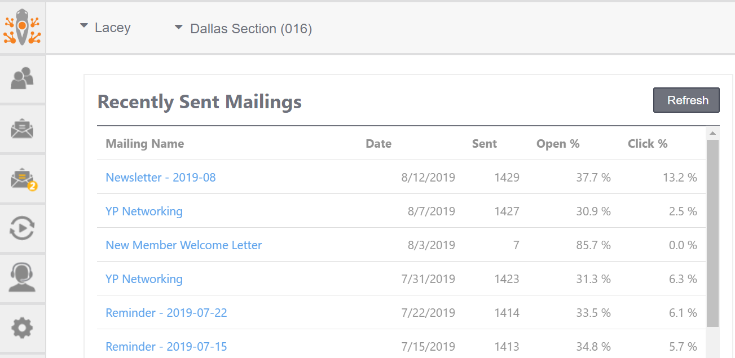

Create a Mailing.
Select the Mailings menu (envelope icon), Create, Mailing
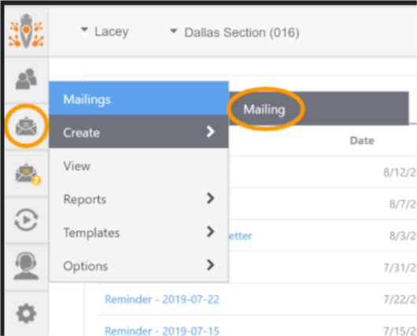

Set-Up tab
Properties
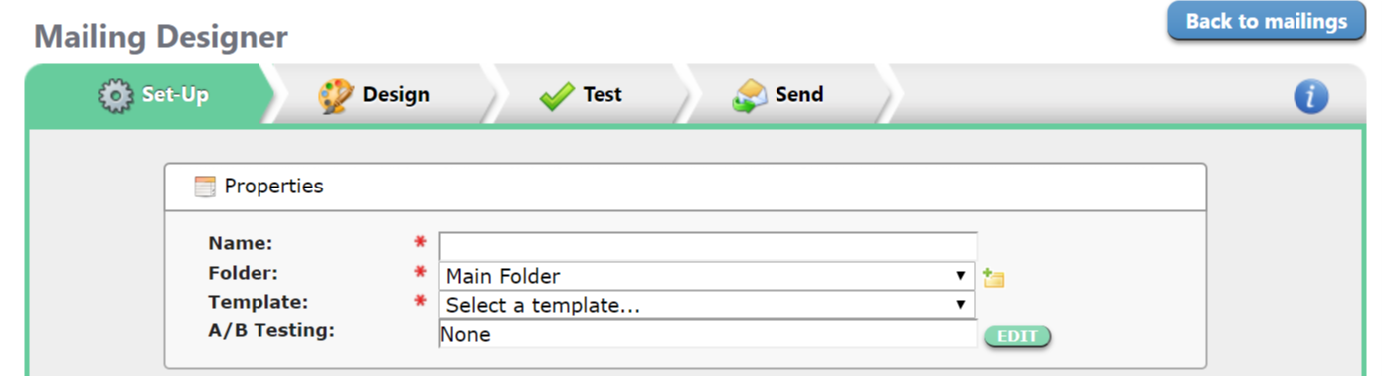

Name—create a title describing the content of the mailing.
Recipients will not see this title and is for organizational purposes. It is not the subject line.
Folder—Choose Main Folder or create a new folder. To create a new folder, select on the folder icon.
The folder is for organizational purposes. You can organize your mailings by creating folders that specify the type of mailings, such as “2016 newsletters”, “announcements”, etc.
Template – choose Basic Email or Newsletter
Basic Email Newsletter
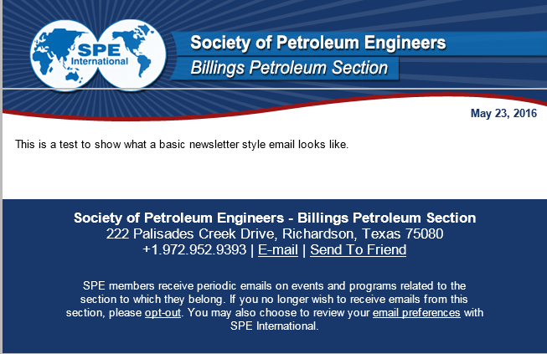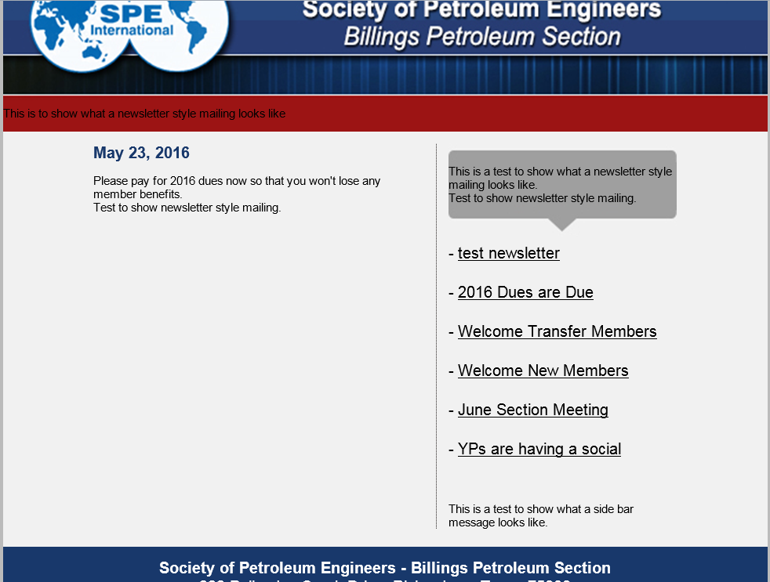

Choose the Basic Email template when you want to send a quick email to welcome new members or a meeting notice. Choose the Newsletter template when you have multiple stories—such as announcements and events.

A/B Testing—select None. This is used for high-level market testing to test variations of your mailing.
Envelope
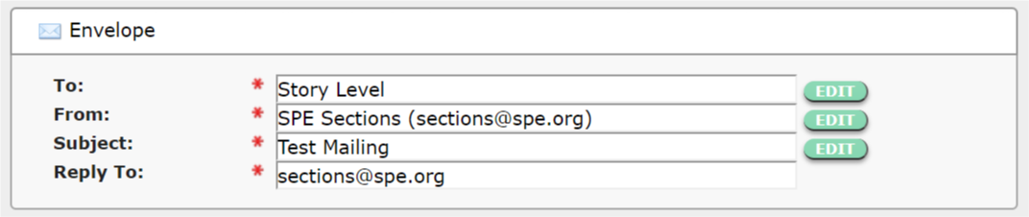
To—select EDIT to select the recipients of your mailing.

Targeting Emails
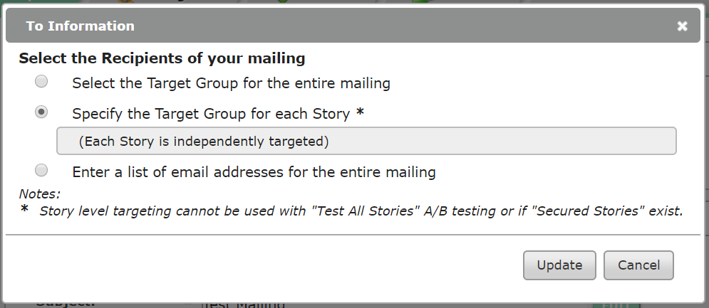

“Select the Target Group for the entire mailing” or “Specify the Target Group for each Story.” Do not select “Enter a list of email addresses for the entire mailing”. It is against global privacy laws to add on-members to the email system.

Select the Target Group for the entire mailing if you intend to send the same email content out to all members.
Targeting by Story
When sending messages to different Target Groups, it is best practice to select the Target Group for each Story option if you intend to target multiple groups using the same mailing—YPs, unpaid members, or new members, and more. This prevents the need to send one mailing, make a copy, and send another.
From—this field should autofill, usually with your SPEmail account.
Subject—enter a concise subject that will entice readers to open your mailing
If you really want to get advanced, you can change the subject to a Targeted Subject and have different subject lines as well as stories.
Save—you must save your work to move to the next tab
Reply to—this field should autofill, usually with your SPEmail account. Hint – Don’t forget to check this email account for your replies.

Design tab
Select the Create Story link to open up the HTML editor.
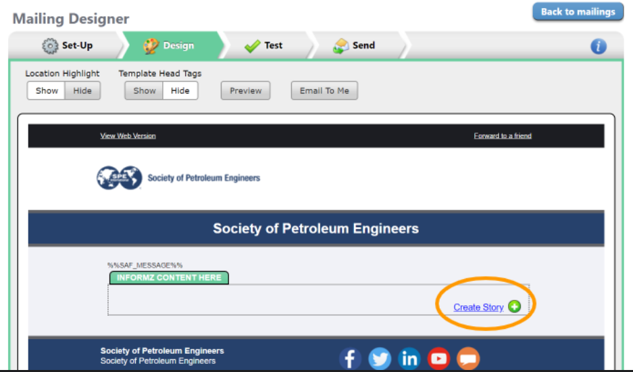
If you chose Select the Target Group for the entire mailing, you will see this HTML editor:
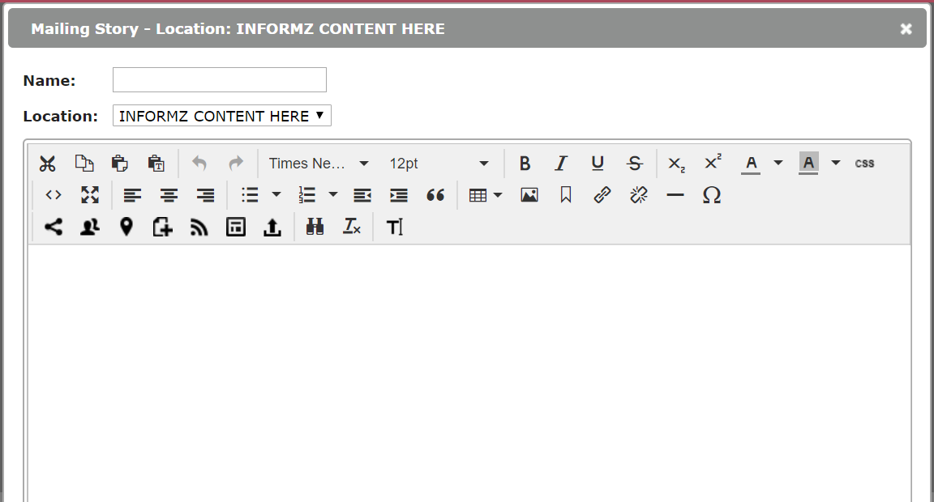
If you chose Specify the Target Group for each Story, you will see this HTML editor.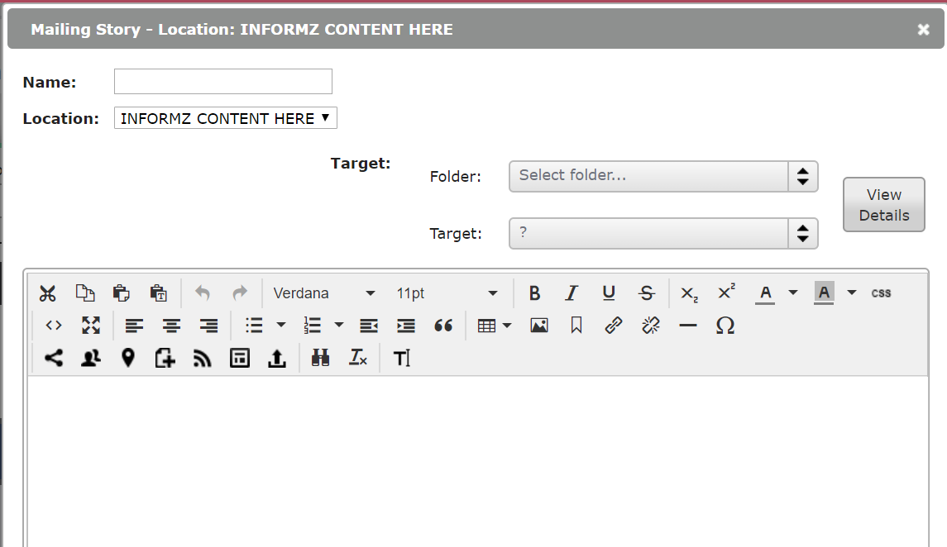
Name—for this specific story, such as “Renewal Reminder”
Folder—select Personify 360 MKT Lists
Target—select your target group for this specific story, such as Members Unpaid

Personalization Codes
It is recommended to personalize your content using the Personalization icon. This helps further target your mailings.
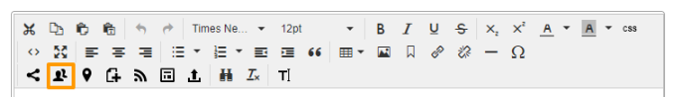
After selecting the, icon, choose Informz for Personify 360 from the drop-down menu. Then, select which code you would like to use. This works similarly to a mail merge.
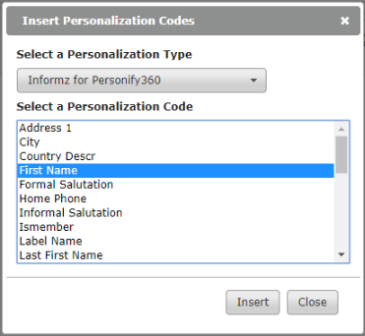
Once inserted, compose the rest of your message content around the code.
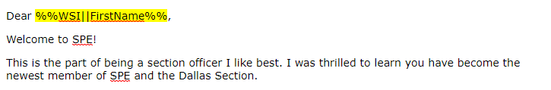

Images
Select the Images icon to insert an image.
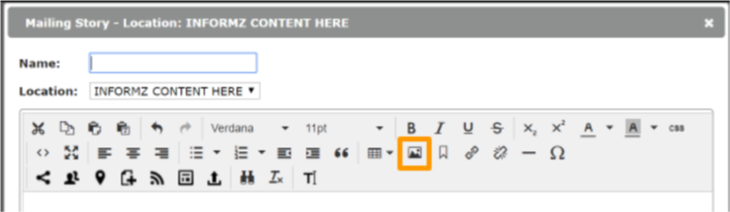
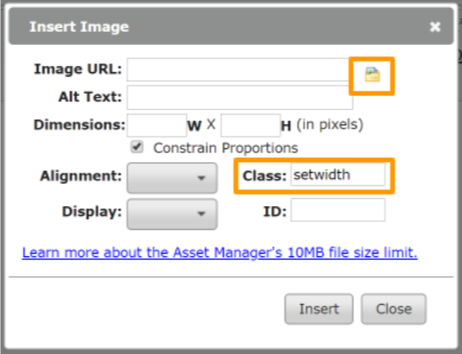
Copy/paste the image URL or select the folder icon to upload your own image into the Asset Manager. Note: The max file size for an image is 10 MB.

Distinguished Lecturer Templates (Story Layouts)
Select the Story Layouts icon.
Select the Main Folder and choose your upcoming DL’s name. Then, edit the meeting date, time, location, and any other important details. Do not forget to change the text color! Select the Insert button when done editing.
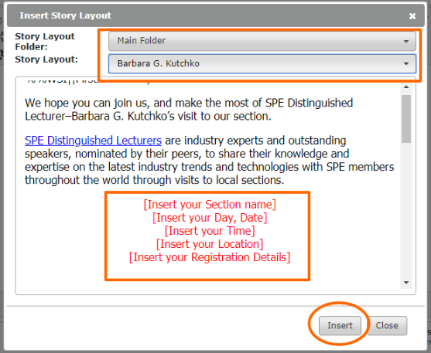

Creating a Downloadable Calendar Appointment (vCalendar)
You can link to a calendar (.ics) file in a mailing. If a recipient clicks on this link, the calendar file writes a new appointment into the recipient’s calendar program—such as Outlook.
To create the vCalendar file, select vCards & vCalendars from the Mailings (envelope icon) menu.
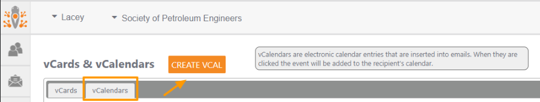
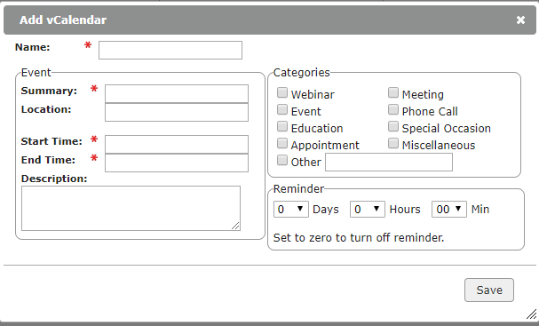
Name—only shows up in Informz as the title
Summary—appears as the subject of the Calendar entry
Location—of the meeting/event
Start Time/End Time—of the meeting/event

Description—will be the main content in the calendar entry.

Categories—select those that describe your event

Reminder—you can set a time interval when the recipient will receive a reminder about the event.

Save—must be selected to create your meeting/event entry.

Example of a calendar entry that is created from the Informz input:
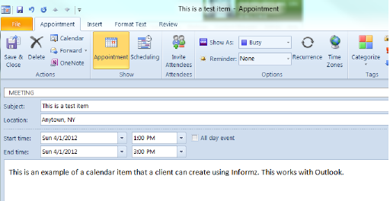
After creating the Calendar entry, it becomes available to insert as a hyperlink in the HTML content editor.
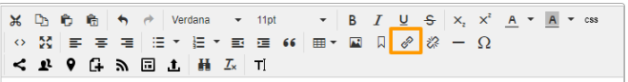

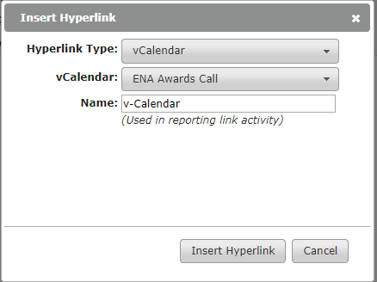

When are done composing your mailing content, select the Save button at the bottom. Repeat these steps for as many stories as you would like to include.
Hover over the story and 4 icons will appear in the top, right corner—Create Below, Edit, Copy, and Delete. You may also rearrange your stories by selecting the Move icon in the top, left corner.
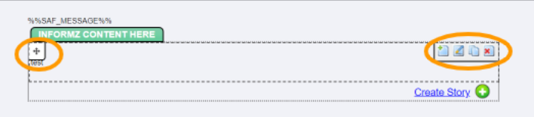

Your mailing might look extremely long and scary, but each target group will only see the stories meant for them.

Test tab
Always preview and test your mailing before sending!
The test option allows you to send the test email to yourself, validate hyperlinks with in the email, and more. Note: The personalization test does not work, but you can ensure it is working by using the Send Test feature.
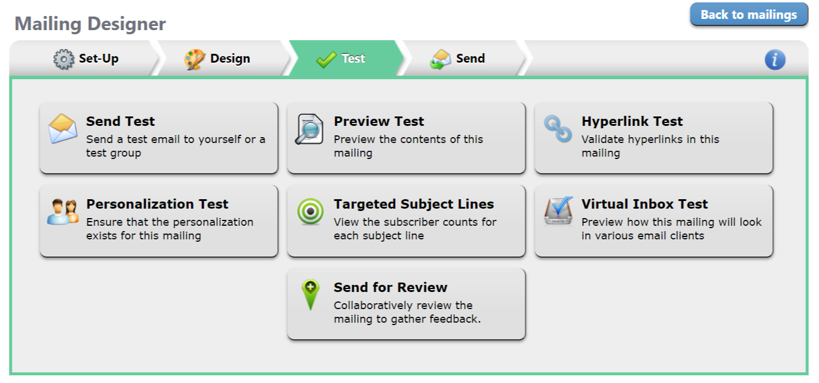
Tip: if you selected Specify the Target Group for each Story, it is best practice to test all versions of the mailing.

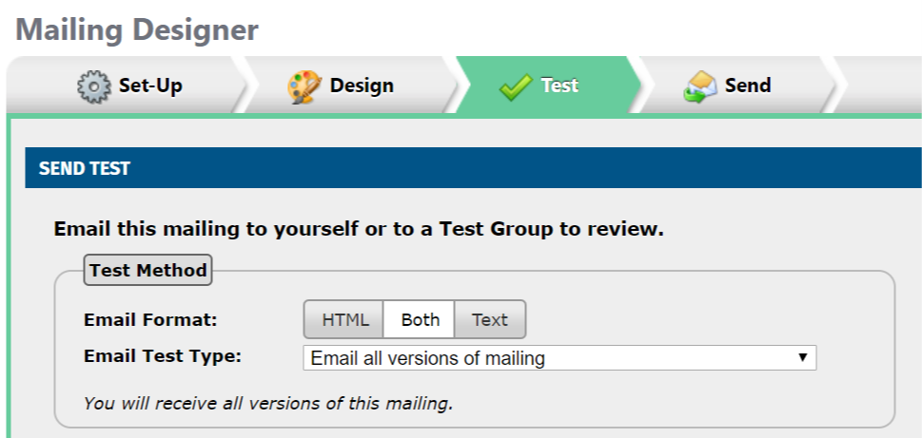

Send tab
Send Mailing Now—as it implies, this option sends your mailing right away. Be cautious and ensure you have thoroughly previewed and tested your mailing.
Schedule Mailing—select a future date/time to send your mailing. TIP – This option is ideal for setting up a monthly email to new members and transferred members.
If you frequently email the same group of people, you can select “Optimized” this option sends an email over 24 hours, allowing the email to deliver at the average time that the user opens email.

Scheduling monthly automated emails works well for recurring messages—such as:
- New member welcome
  - Use the New Members from the Previous Month target group (sections)
  - Use the New students from Previous Month target group (student chapters)
- Transferred member welcome
  - Use the Transferred Members from the Previous Month target group (sections)
- Sharing the FREE professional membership offer for graduates
  - Use Students Graduating Next Month target group (student chapters)

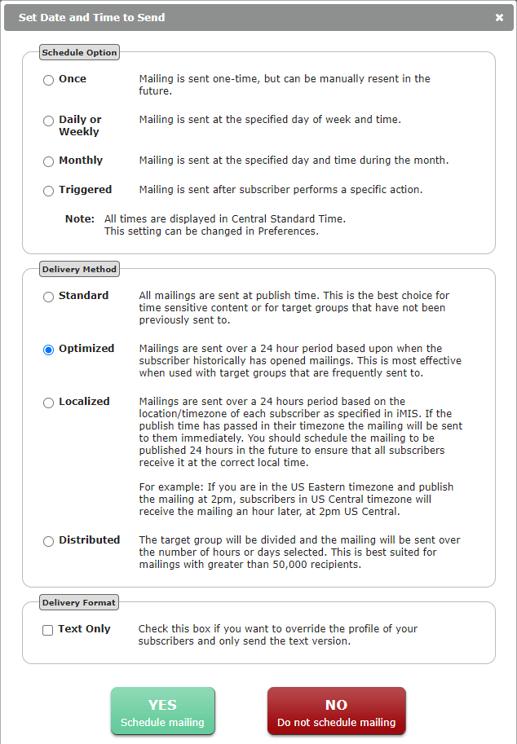

View your reporting.
View the delivery and open rate of your mailings and make sure your members receive your mailings. For example, if a select number of members are not receiving emails, you can determine the cause by reviewing your reports. In addition, you can generate reports of members that are active subscribers and unsubscribed members.
From the Home Screen, Under Recently Sent Mailings, select on one of your mailings—or select Reports from the Mailings (envelope icon) menu.
The Snapshot tab provides a quick overview of the delivery, open, and click rates of your mailing.
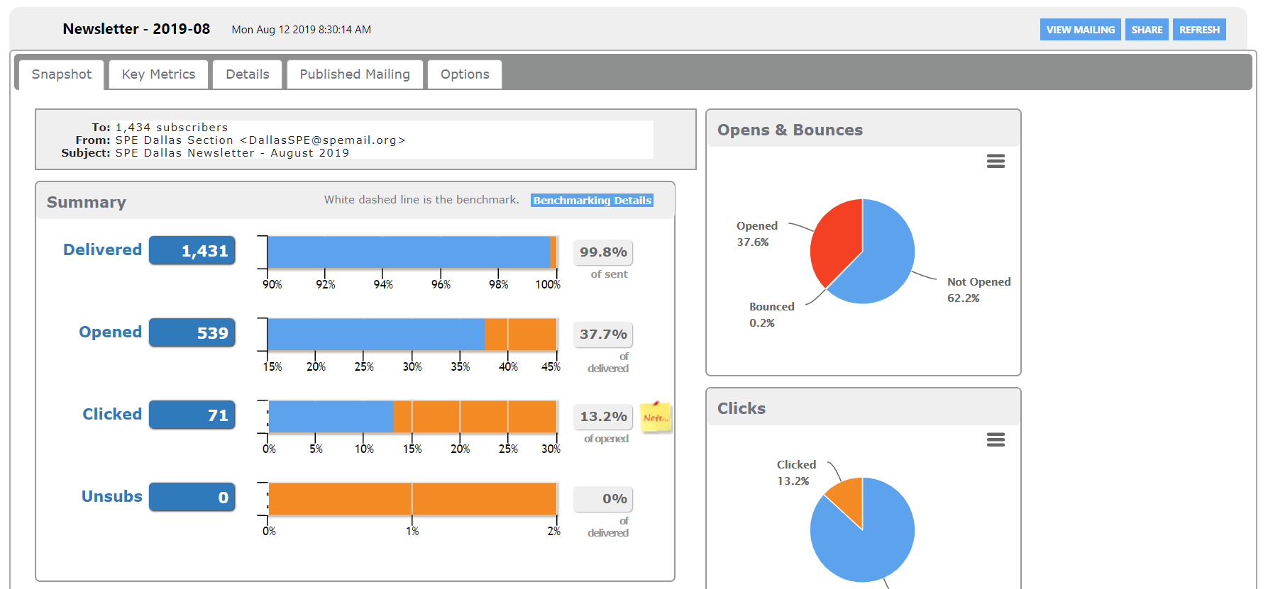
The Key Metrics tab Indicates specifics of those delivered and non-delivered.
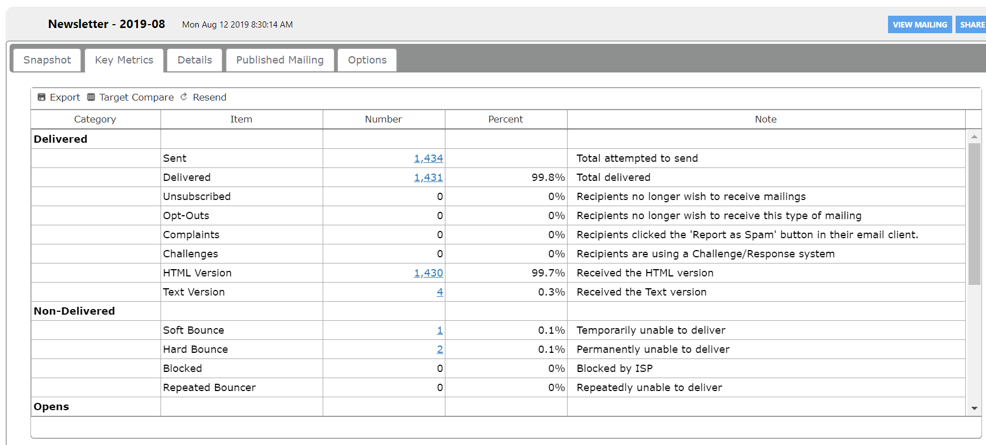
The Details tab lists the email addresses sent to (hidden for privacy purposes in the screenshot below), those delivered, opened, and clicked.
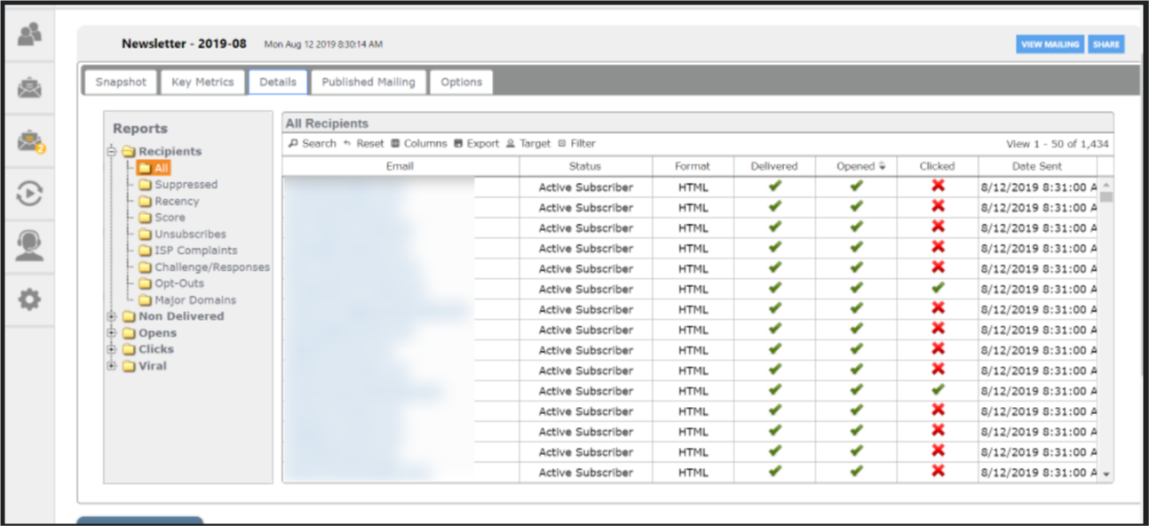

Tips to Avoid Spam Filters
Try these tips to avoid spam filters and better ensure delivery of your mailings:
- Encourage recipients to classify mailings as ‘not spam’
- Keep messages consistent with your ‘from address’
- Ask recipients to add the ‘from’ email address to the safe senders list
- Check your mailing content for spam triggers such as
  - Exposed URLs
  - Excessive image use
  - Suspicious subject lines
  - “!” or words like “FREE” in the subject line
  - Including attachments
  - Bright red text
- Ask recipients to have their IT department whitelist your Informz IP address (email us at sections@spe.org or chapters@spe.org for your IP address)

If a member reports not receiving communications via Informz, check the subscriber details to see if they have received, opened, or clicked emails, as well as their subscription status.
There are more detailed articles in the Informz Knowledgebase:
