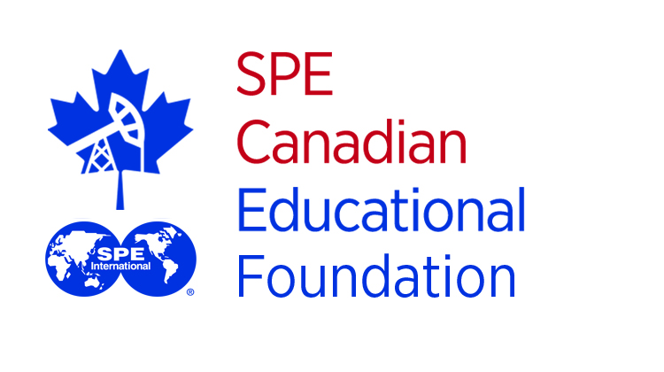

Hello Students,

This year, the Society of Petroleum Engineers Canadian Educational Foundation (SPECEF) will be awarding several scholarships to students across the country pursuing a degree or diploma with intentions to enter the Energy Industry upon graduation. These scholarships are open to students studying at all institutions in Canada. SPECEF will be awarding multiple scholarships to highly qualified students.
Note that all scholarship applicants must be Canadian citizens or permanent residents to be eligible.
This year’s deadline for applications is December 19, 2019.
Please visit www.spe.org/canada for more details and remember to sign up for your SPE membership today (membership for students is free!)

SUBMISSION REQUIREMENTS:
Scholarship recipients will be selected by a committee through a competitive process. Students submitting applications for scholarships must meet the following requirements:
  - Be enrolled full-time in any diploma or degree program with interest in entering the Energy industry (note that programs outside of engineering and graduate level programs DO qualify).
  - Be an SPE member at the time of your application. If you are not a member, you can easily register for free at www.spe.org.
  - Hold satisfactory academic standing (as determined by the SPE Scholarship Committee)
  - Extra-curricular activities through SPE, university and community or other volunteer work.

SUBMISSION FORMAT:
Scholarship applications must follow the guidelines below and include all the following files:
- A cover letter no longer than 350 words addressed to Mr. Jeffrey Lade, SPECEF Student Scholarships. Cover letter must address the following:
- Why do you deserve this scholarship?
- How would this scholarship benefit you?
- What are your extra-curricular activities and/or SPE involvements?
- A copy of your current resume
- A copy of your latest transcripts (unofficial is acceptable)
- A completed copy of the Scholarship Application Form
- All submissions shall be PDF format, file size no larger than 5 MB consolidated

*Please note that the quality of your application will be taken into account by an SPE Scholarship Committee. Make sure you have all documents enclosed and that they are clear and readable. Please refrain from submitting additional documents that are not supporting your application directly.

SUBMISSION:
Please submit applications by email to Jeffrey Lade at jefflade8 @gmail.com, and CC Kristin Briard at specef@spe.org.

Thank you and good luck,
2019 SPE Canada Education Foundation Scholarship Team

